**双向循环链表**

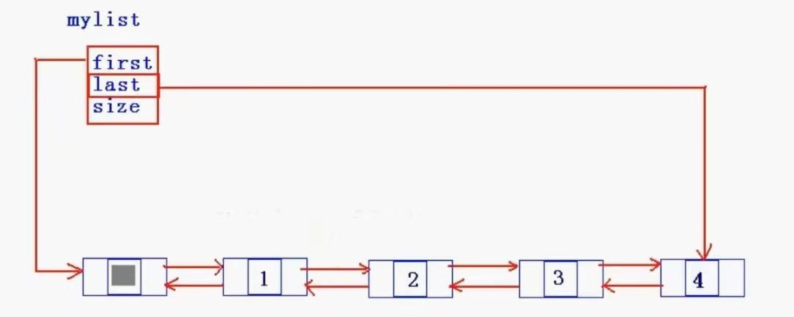

#include <stdio.h> //标准输入输出的头文件

#include <malloc.h>

#include <assert.h>

typedef int ElemType;

typedef struct Node {

ElemType data;

struct Node* prio;

struct Node* next;

}Node, * PNode;

typedef struct List {

PNode first;

PNode last;

int size;

}List;

void InitDList(List* list) {

PNode s = (PNode)malloc(sizeof(Node));

assert(s != NULL);

list->first = list->last = s;

list->last->next = list->first;

list->first->prio = list->last;

list->size = 0;

}

PNode _buynode(ElemType x) {

PNode s = (PNode)malloc(sizeof(Node));

assert(s != NULL);

s->data = x;

s->next = s->prio = NULL; //和先前单链表不同 这里购买结点的时候要考虑前趋和后趋

return s;

}

void push_back(List* list, ElemType x) {

PNode s = _buynode(x);

s->next = list->last->next; //这边两句是构成循环的很重要的两句

s->next->prio = s; //s的后趋变成了头，头的前趋指向s，形成循环

s->prio = list->last;

list->last->next = s;

list->last = s;

list->size++;

}

void push_front(List* list, ElemType x) {

PNode s = _buynode(x);

s->next = list->first->next; //如果是第一个结点，那么这两句是构成循环很重要的语句，建议画图分析

s->next->prio = s;

s->prio = list->first;

list->first->next = s;

if (list->first == list->last) {

list->last = s;

}

list->size++;

}

void show_list(List* list) {

Node* p = list->first->next;

while (p != list->first) { //循环链表的while循环终止条件为指向头

printf("%d-->", p->data);

p = p->next;

}

printf("Nul.\n");

}

void pop_back(List* list) {

if (list->size == 0) {

return;

} //和普通双向链表不同的地方 普通双向链表需要从头有个指针进行遍历

PNode p = list->last;

list->last = list->last->prio;

p->next->prio = p->prio;

p->prio->next = p->next;

free(p);

list->size--;

}

void pop_front(List* list) {

if (list->size == 0) {

return;

}

PNode p = list->first->next;

p->next->prio = p->prio;

p->prio->next = p->next;

if (list->first->next == list->last) {

list->last = list->first;

}

free(p);

list->size--;

}

void insert_val(List* list, ElemType x) {

PNode p = list->first; //插入数据要从头结点开始遍历去寻找位置

while (p->next != list->last && p->next->data < x) {

p = p->next;

}

if (p->next == list->last&&p->next->data<x) {

push_back(list, x);

}

else {

PNode s = _buynode(x);

s->next = p->next;

s->next->prio = s;

s->prio = p;

p->next = s;

list->size++;

}

}

PNode find(List* list, ElemType key) {

PNode p = list->first->next; //寻找数据则从第一个有数据的结点开始

while (p != list->first && p->data != key) { //两个条件不可以交换顺序

p = p->next;

}

if (p == list->first) { //对于循环链表的查找值的操作

return NULL;

}

return p;

}

int length(List* list) {

return list->size;

}

void delete_val(List* list, ElemType key) {

if (list->size == 0) { return; }

PNode p = find(list, key); //先找到数据的位置

if (p == NULL) {

printf("要删除的值不存在.\n");

return;

}

//与单向链表不同的是不需要用后面的数据覆盖要删除的数据

if (p == list->last) {

pop_back(list);

}

else {

p->prio->next = p->next;

p->next->prio = p->prio;

free(p);

list->size--;

}

}

void sort(List* list) {

if (list->size == 0 || list->size == 1) {

return;

}

PNode s = list->first->next;

PNode q = s->next;

list->last->next = NULL; //千万不能忘了这一行 这一行是打破循环 为断开链表做准备

list->last = s;

list->last->next = list->first;

list->first->prio = list->last; //到这一步为止已经重新建立了循环

while (q != NULL) {

s = q;

q = q->next;

PNode p = list->first; //插入数据要从头结点开始遍历

while (p->next != list->last && p->next->data < s->data) {

p = p->next;

}

if (p->next == list->last) {

//s结点已经存在，所以尾插的方法我们要自己重新编写

s->next = list->last->next;

s->next->prio = s;

s->prio = list->last;

list->last->next = s;

list->last = s;

}

else {

//常规插入 修改四个指针

s->next = p->next;

s->next->prio = s;

s->prio = p;

p->next = s;

}

}

}

void resver(List* list) {

if (list->size == 0 || list->size == 1) {

return;

}

PNode p = list->first->next;

PNode q = p->next;

list->last->next = NULL;

list->last = p;

list->last->next = list->first;

list->first->prio = list->last;

while (q != NULL) {

p = q;

q = q->next;

p->next = list->first->next; //进行头插

p->next->prio = p;

p->prio = list->first;

list->first->next = p;

}

}

void clear(List* list) {

//进行头删 直到删除所有结点

if (list->size == 0) {

return;

}

PNode p = list->first->next;

while (p != list->first) {

//常规头删操作

p->next->prio = list->first; //这里就不要考虑是不是最后一个结点了

list->first->next = p->next;

free(p);

p = list->first->next;

}

list->last->next = list->first; //构成循环

list->size--;

}

void destroy(List* list) {

clear(list);

free(list->first);

list->first = list->last = NULL;

}

void main() {

List mylist;

InitDList(&mylist);

int select = 1;

int Item;

PNode p;

while (select) {

printf("**********************************\n");

printf("*[1]push_back [2]push_front *\n");

printf("*[3]show_list [4]pop_back *\n");

printf("*[5]pop_front [6]insert_val *\n");

printf("*[7]find [8]length *\n");

printf("*[9]delete_val [10]sort *\n");

printf("*[11]resver [12]clear *\n");

printf("*[13]destroy [0]quit_system *\n");

printf("**********************************\n");

printf("请选择：>");

scanf_s("%d", &select);

if (select == 0) {

break;

}

switch (select) {

case 1:

printf("请输入要插入的数据（-1结束）:>");

while (scanf_s("%d", &Item), Item != -1) {

push_back(&mylist, Item);

}

break;

case 2:

printf("请输入要插入的数据（-1结束）:>");

while (scanf_s("%d", &Item), Item != -1) {

push_front(&mylist, Item);

}

break;

case 3:

show_list(&mylist);

break;

case 4:

pop_back(&mylist);

break;

case 5:

pop_front(&mylist);

break;

case 6:

printf("请输入要插入的数据:>");

scanf_s("%d", &Item);

insert_val(&mylist, Item);

break;

case 7:

printf("请输入要查找的数据:>");

scanf_s("%d", &Item);

p = find(&mylist, Item);

if (p == NULL) {

printf("查找的数据在链表中不存在.\n");

}

break;

case 8:

printf("双向循环链表的长度为:> %d \n", length(&mylist));

break;

case 9:

printf("请输入要删除的值:>");

scanf_s("%d", &Item);

delete_val(&mylist, Item);

break;

case 10:

sort(&mylist);

break;

case 11:

resver(&mylist);

break;

case 12:

clear(&mylist);

break;

case 13:

destroy(&mylist);

break;

default:

printf("输入命令错误，请重新输入。\n");

break;

}

}

}